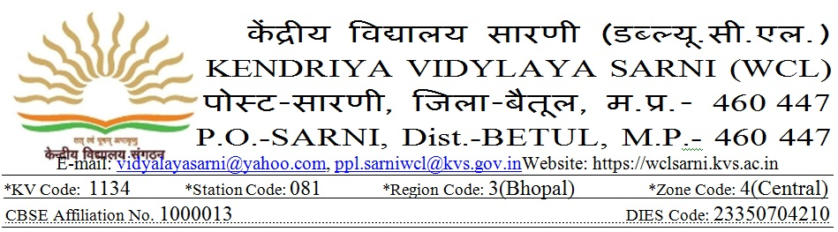
BIODATA / Application Form

Photograph
Post Applied for…………………………….…………………………
on contractual part-time basis for the academic session 2021-22
1. Name (In Capital) :-……………………………………………………………………………………..…………
Name (in Hindi):- …………………………………………………………………………………..……………
2. Date of Birth: ……………………………… Gender (Male/Female): ……………………....………
3. PAN No :-………………………………………….. 4. AADHAR No. ………………………………………….
5. Category (SC/ST/OBC/Gen): ………………..………… 6. Marital Status ……..…………………………………………….….………..
7. Contact Address: ………………………………………………………………………………………………………………..……………………………
City……………………….…………….…………District………………….………….…..………State…………………………………………..…….
7. Phone No. with STD Code: ………..…………………….………………E. mail ……………….……………………….…….…………………….
8. Mobile No.: (1)…………………………..……………… (2) …………………….………………………(3)…………….……………………………….
9. Academic Qualification (Starting from High School level)
(Please give information as applicable. (Attach attested copies of Mark sheets and Certificates)
Name of Examination  (with complete name of course passed) | Write name of Examination passed | Year of passing | AGGREGATE MARKS |  |  | Subjects /Specialization | Duration  of course  (in months) | Board/  University
 |  |  | Max.  Marks | Marks obtained | %age of marks
High School (X)
Higher Secondary (XII)
Graduation
(Name of Course)
Post Graduation
(Name of Course)
Others if any
(Specify)
GRADUATION SUBJECTS  (ONLY FOR TGT POST) | SUBJECT -1 |  |  | SUBJECT -2 |  |  | SUBJECT -3
 | Max.  Marks | Marks obtained | % Marks | Max.  Marks | Marks obtained | % Marks | Max.  Marks | Marks obtained | % Marks
1 YEAR
2 YEAR
3 YEAR
TOTAL

Note: - Please provide information for the qualification completed by 1th March 2021 only.
10.Professional Qualification (Attach attested copies of mark sheets & certificates)
Name of Examination  (with complete name of course passed) |  | Write name of Examination passed | Year of passing | AGGREGATE MARKS |  |  | Subjects /Specialization | Duration  of course  (in months) | Board/  University
 |  |  |  | Max.  Marks | Marks obtained | %age of marks
CTET (I to V)
Qualified
CTET (VI to VIII)
Qualified
B.ED/JBT/DED | Theory
 | Practical
MBBS Degree /Diploma in Nursing / Counseling/Yoga
Other if any
(specify)

11. Experience (Attach certificates if experience is in the recognized Schools) – priority will be given.
Post held | Name of Institution | Period of service |  | No. of completed years & months | Class taught | Subjects taught | Scale of pay and salary per month
 |  | From | To
12. Are you able to teach through English and Hindi, both?
NO

YES

(Please mark (√) tick in the appropriate box) For teaching posts
13. Do you have knowledge of computer application?
NO

YES

(Please mark (√) tick in the appropriate box) For teaching posts
UNDERTAKING
I hereby certify that all the information given above is true and correct to the best of my knowledge. I have attached attested copies of my testimonials in support of the entries made above. I also agree that mere eligibility does not confer right to be called for interview/selection. My candidature may be cancelled in case any information is found to be incorrect on verification.

Place______________

Date_______________
Signature_______________________
Contact No. Name_________________________

